**Backlog Refinement Meeting Agenda 3/26/2025**

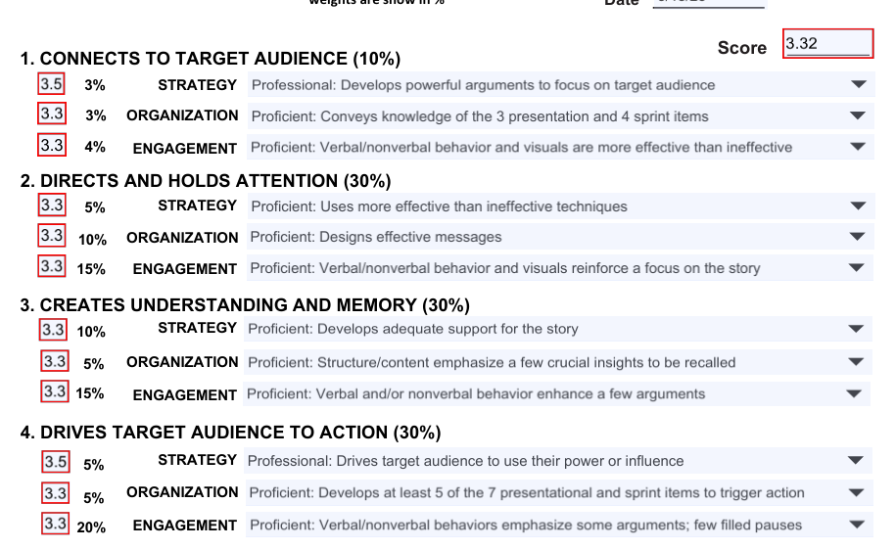

Stephanie??????

- Numerous filled pauses due to poor breathing; the shallow breaths result in making the filled pause instead of taking a breath at that time

- speech rate too fast; a faster rate can be due to reading

- The DFD story seemed to wander; the one visual was up for a long time even though it was merely Stephanie Creates with no development

- Building the slides worked once it began but the builds seem to have a delay from the story

- Build was done well for "item inventory"

Hannah

- Click on Hide to elimnate the tag from distracting; I talked about this in my comments

- speech rate fast and monotone; could be the result of reading

- Speech rate better for Hardware/Software

- Make logo smaller for the navigation visual

Heather

- Volume high; a mike check could help before starting the presentation

- Speech rate effective creating emphasis on

- Excellent storytelling for the conclusion

Overall- make sure that all diagrams have consistent labels

1. 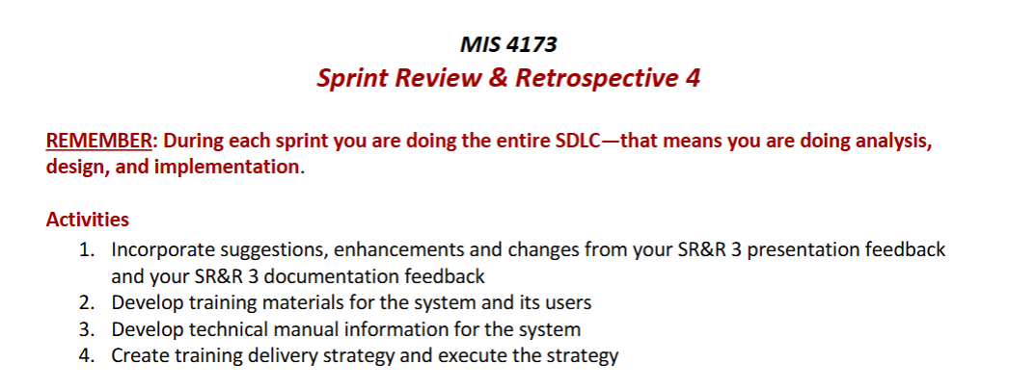
2. 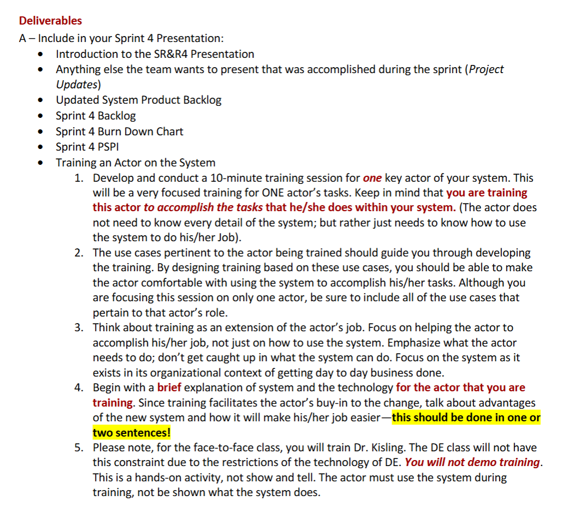
3. 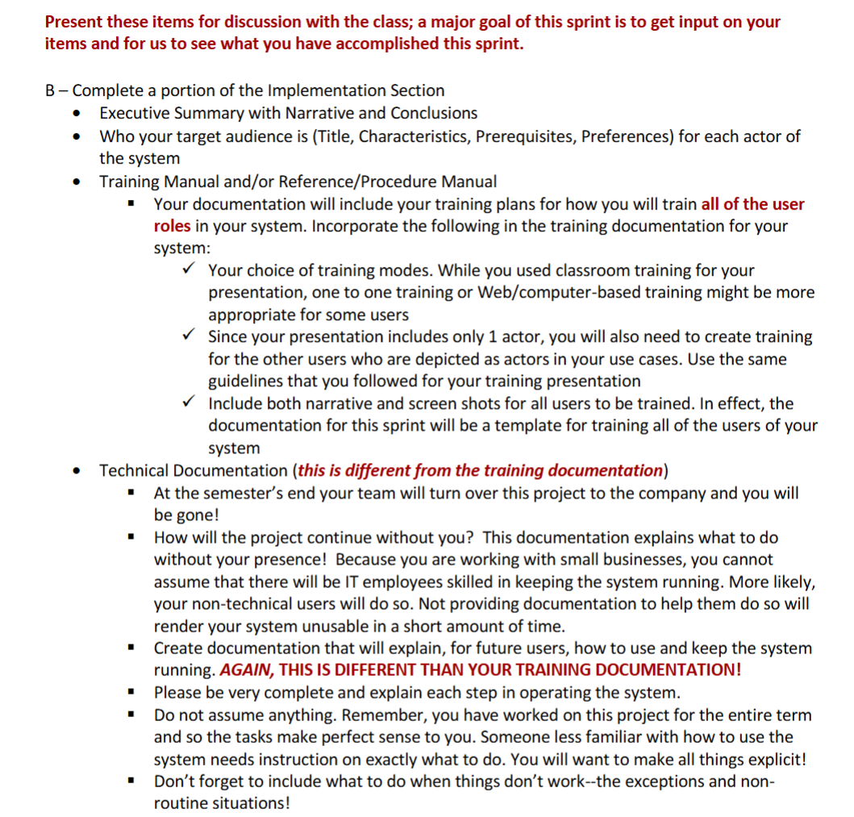
4. 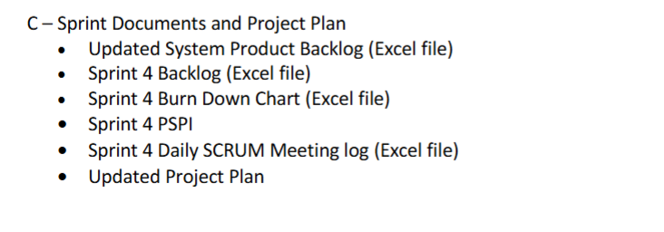5. 